*Florida International University*

*School of Computing and Information Sciences*

Software Engineering Focus

Feature Document

User Story ID <813>

**Name: Carlos Martinez**

**Team Member(s): Mairim Barios, Arelys Alvarez, Fidel Hernandez, Samira Tellez**

**Project:AR-VR-VE for Computer Science**

**Product Owner(s)**: Dr. Francisco Orega

**Mentor(s)**:

**Instructor**: Masoud Sadjadi

**User Story Name: Character Movement with Illusion**

* Description: **As a developer I would like to have it so that the user can move through the whole maze and not realize that the maze is an illusion**

Acceptance Criteria

* Have the character move smoothly across the maze

**Use Case**

* Name: User advances past maze “gap”
* Actor: Player
* Preconditions: User is about to traverse past the illusion part of the stage
* Description <Player inputs commands to move character past illusion and the character does so without the player noticing the trick>:

**Use Case Diagram**

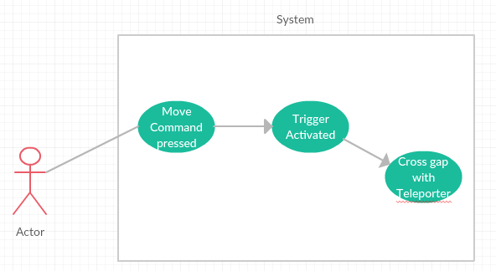

**Sequence Diagram**

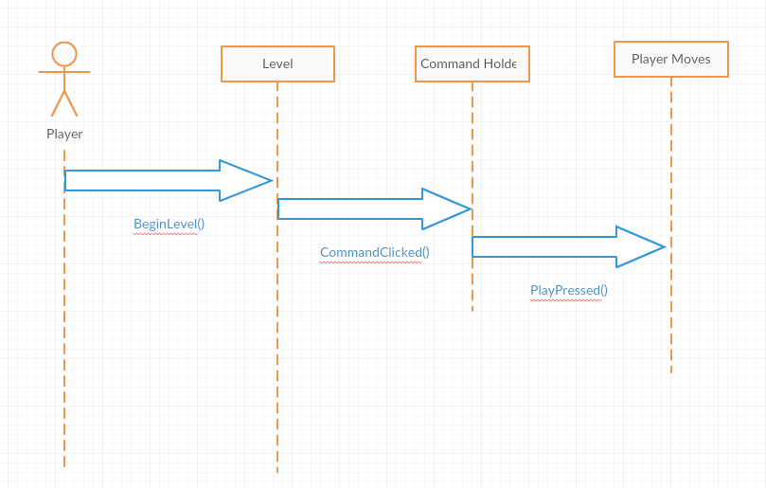

**Class Diagram**

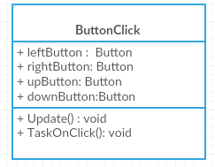

User Story ID <814>

**Name: Carlos Martinez**

**Team Member(s): Mairim Barios, Arelys Alvarez, Fidel Hernandez, Samira Tellez**

**Project:AR-VR-VE for Computer Science**

**Product Owner(s)**: Dr. Francisco Orega

**Mentor(s)**:

**Instructor**: Masoud Sadjadi

**User Story Name: Character Movement with polymorphism**

* Description: **As a user I would like my character to polymorph into different objects so that they can solve interesting weight based puzzles**

Acceptance Criteria

* Have the character be able to change its weight or movement properties with different objects

**Use Case**

* Name: User gets properties of boulder
* Actor: Player
* Preconditions: User is atop a button they cannot press due to not being heavy enough
* Description <Player inputs polymorph command and chooses to polymorph into a rock to change the character’s weight so that it can now press the button>:

**Use Case Diagram**

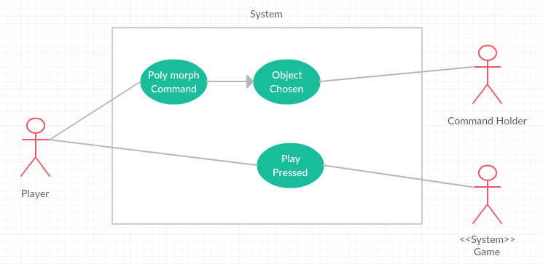

**Sequence Diagram**

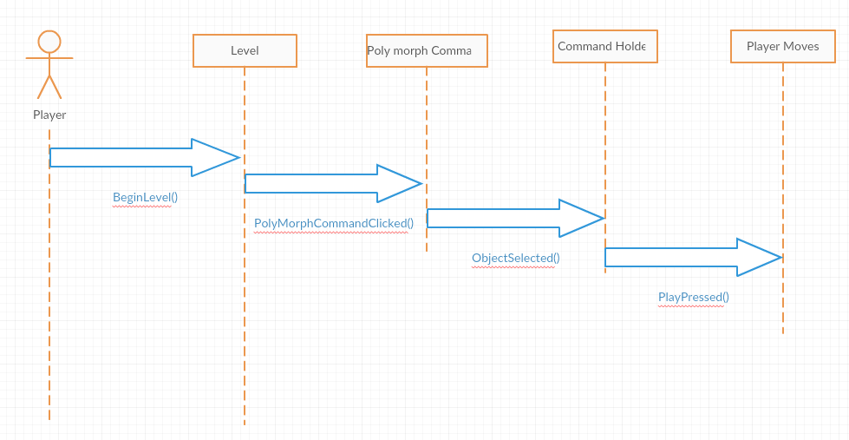

**Class Diagram**

